Introduction to the Louisiana Master Naturalist Program of
Greater Baton Rouge

“In every walk with nature one receives far more than he seeks.” John Muir

Oh, the Places You Will Go and the Things You Will See
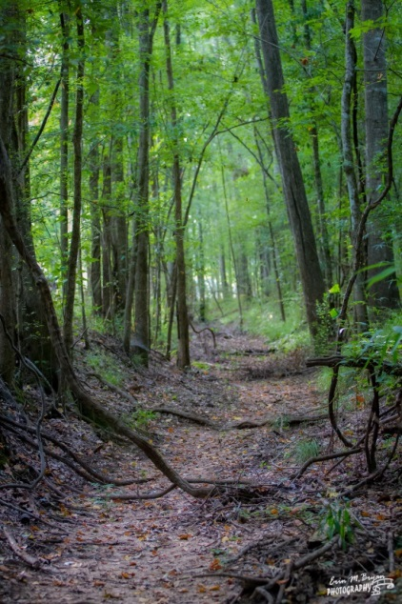
Congratulations on taking such a huge step toward becoming a Louisiana Master Naturalist and on becoming a member of the Greater Baton Rouge group! You are now on your way toward helping improve Louisiana’s natural resources and joining other members across the state of Louisiana. This education will help you increase your understanding of the natural world and prepare you for stewardship of that world. All you need is the desire to learn, a commitment to attend classes and to become certified.
We Are
We are part of a group of well-informed citizen volunteers who engage in conservation, service and education within our communities. We are dedicated to the beneficial management of our natural resources through conservation, preservation and shared information.
Mission Possible
The mission of the Louisiana Master Naturalists of Greater Baton Rouge (LMNGBR) is to provide awareness, understanding and stewardship of the natural environment by developing a corps of well-informed citizen volunteers dedicated to conservation, education and service with their communities. The primary goals of the organization are to provide scientific, research-based education to the general public for a better understanding of the local natural ecosystems and promote conservation and preservation of native plant and animal life within the habitats’ of the Greater Baton Rouge area.
The LMNGBR will regularly conduct training programs to educate and certify new members and then ensure that those members will continue to be informed through education and field work.
The LMNGBR will also strive to enhance the ability of Master Naturalists to exchange information freely with other Master Naturalists and to communicate the value and accomplishments of the Master Naturalist Program to the public.
Me, a Naturalist?
When you first think of the term “naturalist” maybe you think of nature or someone who studies nature. Naturalists delve into field work as if it is their laboratory. Several people probably come to mind when you think of a naturalist, you may think of John Muir, John James Audubon, or Teddy Roosevelt. These individuals all share one common theme, their love of nature and their desire to investigate and improve their environment. They did this through observation, study, analysis and/or conservation. The interesting thing about these naturalists and many more like them are that they weren’t born this way, they evolved.
John Muir was a factory worker but due to an injury and confinement to a darkened room for six weeks, he rethought his plans for his life and decided to follow his dreams of exploration and the study of plants. From there he became the “Father of National Parks” and helped to create our national park system.
John James Audubon was expected to be a businessman and carry on his family’s business by setting up dry goods stores along the Ohio River. John learned to love nature as he traveled to set up his stores. He used all his extra time to paint and sketch as he traveled. Through a series of events he sold his work to make ends meet and his artistic ability became widely known and appreciated. He learned that he wanted to study nature more than sell dry goods. Being intrigued by birds, he decided to catalogue every bird in North America and thereby a great naturalist was born.
Theodore Roosevelt used his presidency to build our national park system and educate people on conservation. He wrote:
“It is also vandalism wantonly to destroy or to permit the destruction of what is beautiful in nature, whether it be a cliff, a forest, or a species of mammal or bird. Here in the United States we turn our rivers and streams into sewers and dumping-grounds, we pollute the air, we destroy forests, and exterminate fishes, birds and mammals- not to speak of vulgarizing charming landscapes and hideous advertisements. But at last it looks as if our people are awakening. “
We hope that this is the goal you have for yourself. To awaken and take the talents that you have, to build upon them by becoming certified, to continue to learn and evolve into the naturalist you were meant to be.
What is a Master Naturalist?
The term is used to describe citizen volunteers who have been trained in multiple disciplines in the natural world in order to help them understand the connectedness of all things in nature. They have successfully completed a comprehensive training program and have become certified. They maintain their certification by continuing to expand their knowledge by attending education programs and volunteering to assist with programs that need their help. They are volunteers who represent the programs that they train under and in turn, are connected to other Master Naturalists throughout Louisiana and even through North American. All 50 states now have master naturalist programs. These were often developed in conjunction with County Extension offices, offices of Wildlife and Fisheries or through Universities. There may even be several chapters per state. The Alliance of Natural Resource Outreach and Service Programs (ANROSP) help to support member programs. The state groups may work independently to teach classes, assist with volunteer projects or join with other state Master Naturalist groups and organizations.
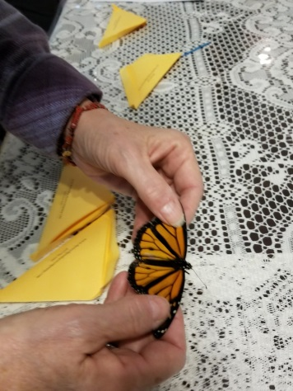
The Louisiana Master Naturalists
A Certified Louisiana Master Naturalists are a group of volunteers that have received training in approximately 40-60 hours of basic training through their organized chapter as established by the Louisiana Master Naturalist Association (LMNA). The LMNA is a state run organization that was established to offer assistance to each state chapter and is represented by members of those chapters. Right now Louisiana has 7 chapters:
Acadiana Chapter (in the Lafayette area) - established 2014
CenLa Chapter (in the Alexandria area) - established Fall 2017
Greater Baton Rouge Chapter- established June 2015
Greater New Orleans Chapter- established Fall 2012
Northeast Chapter (in the Monroe area) - established Fall 2017
Northwest Chapter (in the Shreveport/Bossier area) - established 2014
Southwest Chapter (in the Lake Charles area) - established fall 2015
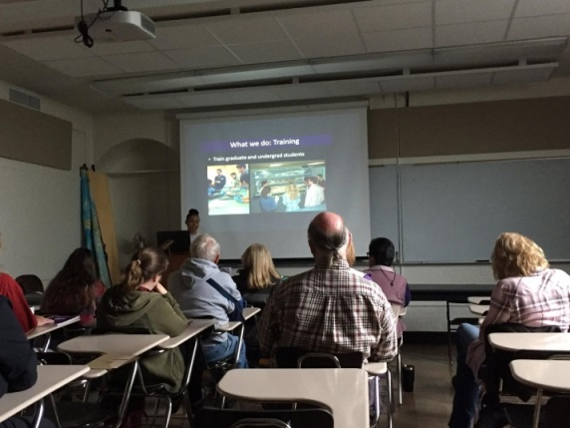
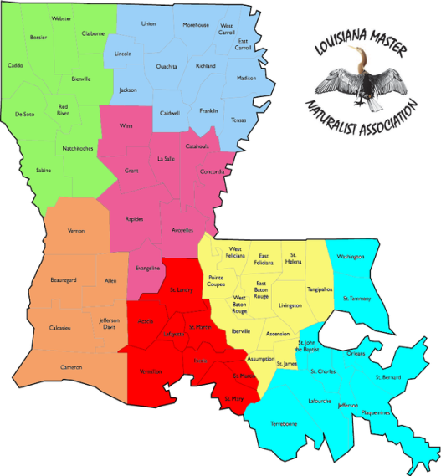
Each chapter follows a set curriculum in order to assure that each member is trained in the necessary skills to be a Louisiana Master Naturalist. To become certified, you will be expected to complete your chosen chapter’s requirements of classroom and field work. This training will be performed by experts in their field: biologists, botanists, geologists, environmentalists, who will help you receive the information that you will need to become educated. While you are being trained, you will be called a “Master Naturalist in Training.” The general fields you will be learning will be arthropods, amphibians and reptiles, birds, forest ecology, mammals, plants, river dynamics, stream ecology, natural history and the nocturnal naturalist.
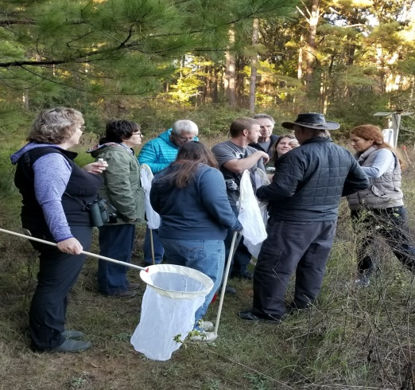
Each module will either be set in a classroom, in the field or both and will include biology, basic science, identifications, classifications and geography. You will need to attend 8 of the 10 workshops in order to be certified and expected to make up at least one of the missed classes by the following year.
As a Master Naturalist in Training you can begin your volunteer hours as soon as you start your course. You will need at least 20 hours of approved volunteer hours per calendar year and at least 10 hours of approved continuing education to maintain certification.
Volunteer Service
There are many benefits to becoming a volunteer but primarily your goal would be to serve your community. Wouldn’t it be great to help enhance an urban landscape by planting a native garden that attracts butterflies and birds or to remove invasive species from our communities or possibly help teach children about the natural history of a pond?
You as a Master Naturalist may learn a new skill, get to meet and work with other people that share similar interests and gain personal satisfaction from helping out your community. Its purpose is to encourage certified Master Naturalists to use their knowledge to enhance their communities through conservation, preservation and education. These hours must be compatible with the curriculum and mission of the LMNGBR program and must be approved by them. There are four ways to achieve volunteer service credits:
- Volunteer in activities within the community that enhance the understanding of natural history and stimulate interest in those topics.
- Earn up to 2 hours of credit for volunteering in each membership meeting attended.
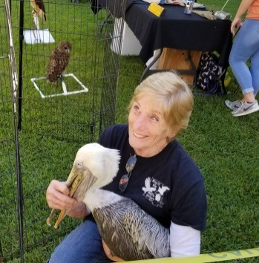
- Volunteer service to the organization of the LMNGBR. The chair of this event must approve these volunteer service hours.
- Serve in an elected position of the LMNGBR Board of Directors.
Below are some ideas:
- Assist with one of the many programming classes or lectures offered by the LMNBR organization
- Volunteer at Wings of Hope
- Volunteer at BREC for tree plantings, outreach events
- Assist at one of our outreach events
- Serve on a committee
- Serve on the LMNGBR board
Responsibilities’ as a Volunteer:
- Commit to the requirement of volunteer hours per year and submitting those hours as soon as you can in Track It Forward.
- Always be honest in submitting the correct amount of time.
- Be respectful of the environment that you find yourself in. Follow Leave no Trace guidelines and leave it better than when you arrived.
- Ensure that a safe environment exists for all volunteers.
- Be considerate of the other members that have also shown up to volunteer. Introduce yourself. Help others that are new.
- Conduct yourself in a professional manner. You not only represent yourself but the LMNGBR group as a whole. Wear you name badge.
- Avoid discrimination in any form. Avoid advocacy, lobbying or promoting political issues.
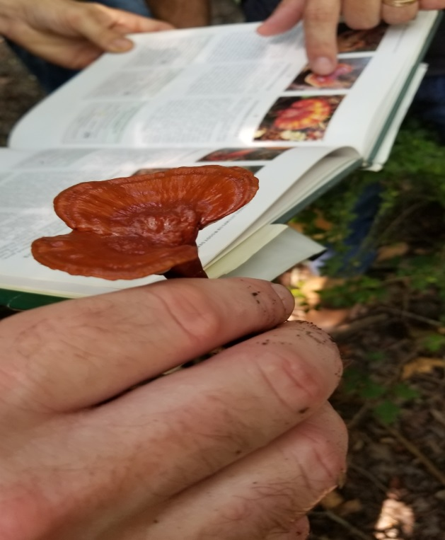
- Make sure that you know your physical limitations.
- Never accept money or a gift for performing volunteer work.
Continuing Education
Continuing education (CE) are classes or activities that expand your knowledge of natural history and scientific literacy. It can be in the form of seminars, workshops r lectures. The purpose of this requirement is to ensure that Certified Louisiana Master Naturalists continue to grow in their knowledge. In order to earn continuing education credits:
- Attend 8 hours of qualifying continuing education workshops
- Earn 1 hours credit for each membership meeting attended.
- Teach a substantial portion of a LMNGBR workshop.
- Be employed or have the full responsibility of volunteer teaching a natural history focused presentation.
Some ideas include:
- Attending “Discover Nature” presentations at the LSU Hilltop
- Attending “Night at the Museum” at the LSU Natural History Museum
- Going on LMNGBR Field trips
- Attending BREC hikes and paddles
- Going on educational bird walks at Bluebonnet Swamp
- Taking a field trip with the Capital Area Native Plant Society
The LMNGBR Calendar is a great resource to find information on volunteering or attaining your education hours. It can be found at www.lmngbr.org/calendar.html or receive The Buzz e-newsletter by signing up at info@lmngbr.org

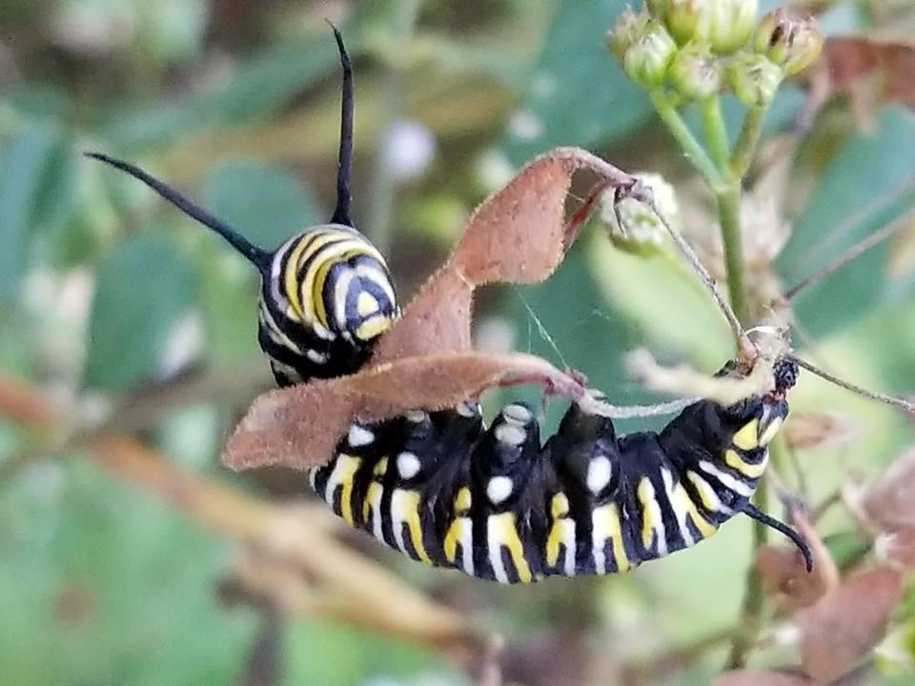
“Adapt the pace of nature: Her secret is patience.” Ralph Waldo Emerson

